Date: ____________
Practical No. 03
Aim: A) Use a dataset with multiple variables and perform correlation analysis to determine the strength and direction of relationships between pairs of variables.
B) Apply regression analysis to identify the relationship between an independent variable (e.g., advertising expenditure) and a dependent variable (e.g., sales revenue).
A) Use a dataset with multiple variables and perform correlation analysis to determine the strength and direction of relationships between pairs of variables.
INPUT:
import pandas as pd
# Dataset
data = {
'Age': [22, 25, 28, 30, 35, 40, 45, 50],
'Experience': [1, 3, 5, 7, 10, 12, 15, 18],
'Salary': [25000, 30000, 35000, 40000, 50000, 60000, 70000, 85000] }
df = pd.DataFrame(data)
# Correlation Matrix
corr_matrix = df.corr()
print("Dataset:")
print(df)
print("\nCorrelation Matrix:")
print(corr_matrix.round(2))
OUTPUT:
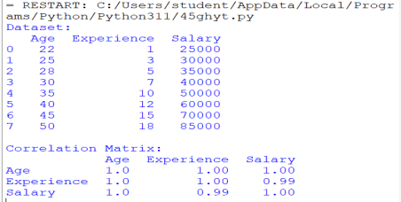Interpretation of Results
Correlation values range from -1 to +1.
+1 → Perfect positive relationship.
-1 → Perfect negative relationship.
0 → No relationship.
Variable Pair | Correlation (r) | Relationship
Age & Experience | 1.00 | Perfect Positive
Age & Salary | 1.00 | Perfect Positive
Experience & Salary | 0.99 | Very Strong Positive

1. Age and Experience (r = 1.00)
Interpretation:
● As Age increases, Experience increases almost perfectly. ● Older employees generally have more years of work experience. ● The relationship is extremely strong and positive.
2. Age and Salary (r = 1.00)
Interpretation:
● As Age increases, Salary increases.
● Older employees tend to earn higher salaries.
● This indicates a nearly perfect positive relationship.
3. Experience and Salary (r = 0.99)
Interpretation:
● As Experience increases, Salary increases.
● The correlation is 0.99, which is very close to +1.
● This is called a Very Strong Positive Correlation.
Conclusion
Age and Experience: Perfect Positive Correlation (1.00)
Age and Salary: Perfect Positive Correlation (1.00)
Experience and Salary: Very Strong Positive Correlation (0.99) Final Report:
The correlation analysis reveals strong positive relationships among Age, Experience, and Salary. The correlation coefficients are close to +1, indicating that as employees become older and gain more experience, their salaries also increase. Therefore, Age and Experience are important factors influencing Salary in this dataset.
OR
INPUT:
import pandas as pd
from sklearn.datasets import load_iris
# Load built-in Iris dataset
iris = load_iris()
# Create DataFrame
df = pd.DataFrame(iris.data, columns=iris.feature_names)
# Display first 10 records
print("Dataset:")
print(df.head(10))
# Calculate correlation matrix
correlation_matrix = df.corr()
# Display correlation matrix
print("\nCorrelation Matrix:")
print(correlation_matrix)
OUTPUT:
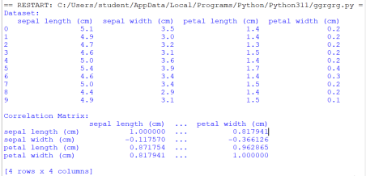Interpretation of Results
● Petal Length and Petal Width = 0.9629
o Very strong positive correlation.
o As petal length increases, petal width also increases.
● Sepal Length and Petal Length = 0.8718
o Strong positive correlation.
o Flowers with longer sepals tend to have longer petals.
● Sepal Length and Petal Width = 0.8179
o Strong positive correlation.
● Sepal Width and Petal Length = -0.4284
o Moderate negative correlation.
o As sepal width increases, petal length tends to decrease.
● Sepal Width and Petal Width = -0.3661
o Weak to moderate negative correlation.
B) Apply regression analysis to identify the relationship between an independent variable (e.g., advertising expenditure) and a dependent variable (e.g., sales revenue)
INPUT:
import pandas as pd
from sklearn.linear_model import LinearRegression
# Dataset
data = {
'Advertising_Expenditure': [10, 20, 30, 40, 50, 60, 70, 80], 'Sales_Revenue': [25, 35, 45, 55, 65, 75, 85, 95]
}
df = pd.DataFrame(data)
# Independent Variable (X)
X = df[['Advertising_Expenditure']]
# Dependent Variable (Y)
Y = df['Sales_Revenue']
# Create and train the model
model = LinearRegression()
model.fit(X, Y)
# Predict sales revenue
predictions = model.predict(X)
# Display dataset
print("Dataset:")
print(df)
# Regression Equation
print("\nRegression Equation:")
print(f"Sales Revenue = {model.coef_[0]:.2f} * Advertising Expenditure + {model.intercept_:.2f}")
# Predicted Values
print("\nPredicted Sales Revenue:")
for ad, pred in zip(df['Advertising_Expenditure'], predictions): print(f"Advertising = {ad}, Predicted Sales = {pred:.2f}")
OUTPUT:
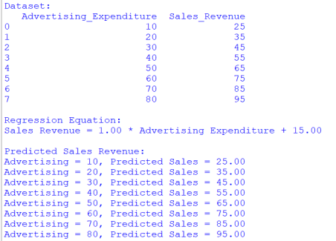Explanation
● Advertising Expenditure is the independent variable (X). ● Sales Revenue is the dependent variable (Y).
● Linear Regression finds the best-fit line relating X and Y.
Regression Equation
Sales Revenue=1.00 × Advertising Expenditure + 15.00
Interpretation:
● For every 1-unit increase in advertising expenditure, sales revenue increases by approximately 1 unit.
● Even when advertising expenditure is 0, the estimated sales revenue is 15 units (intercept).
Conclusion
The regression analysis shows a strong positive linear relationship between advertising expenditure and sales revenue. As advertising expenditure increases, sales revenue also increases proportionally. This helps businesses predict future sales based on advertising investments.

